

Dr. Jonathan, Johns inc.
2022-08-26
Dr. Johns
417 Gonzales Wells Suite 357, Johnsonside, VT 97148
Phone: 2156870814
Fax: 7786574470

Re: Kara, Davidson
PHN: 6435351251
Birthdate: 08-Oct-1960
Address: 208 April Islands Apt. 642, Matthewberg, CT 52652
Patient number: 8331931993

To Whom It May Concern:

This is a medical letter to state the above patient is pregnant with expected delivery date of 29-Jul-2025. Hoping this information is satisfactory for your requirements.

Thank you.

Sincerely,
Dr. Jonathan, Johns
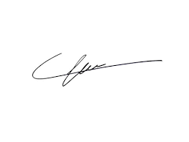
FRCS© NCMP
Clinical Assistant Professor, UBC
Department of Obstetrics and Gynecology SMH

